**University of Lincoln Assessment Framework**

**Assessment Briefing 2022 - 2023**

|  |
| --- |
| **Module Code & Title:** EGR2010 Data Modelling and Simulation |
| **Contribution to Final Module Mark (module weighting):** 25% |
| **Coursework Title:** Coursework |
| **Coursework Issue Date:** 13th March 2023 |
| **Coursework Submission Date & Time:** 24th April 2023, 23:59 |
| **Coursework Feedback Date:** on or before 22nd May 2023 |
| **Description of Assessment Task and Purpose:**  Answer all questions clearly. Use MATLAB only where asked in the question. All other calculations should be shown. |
| **Learning Outcomes (LO) Assessed:**  LO2 Use mathematical techniques and models to generate data and show how understanding, analysis  and hence the design of engineering systems are informed by the underpinning maths  LO3 Design and write structured programmes in a high-level language and use them to solve familiar  real-world engineering problems  LO4 Work and learn independently and communicate results effectively. |
| **Knowledge & Skills Assessed:**  Techniques and Skills Subject-specific knowledge. |
| **Assessment Submission Instructions:**  This submission is:  individual work.  group work.  All work should be submitted by the deadline stated above. Any late submissions will be subject to a lateness penalty in line with the University policy.  The method of submission described above should be used in the first instance however, in cases of technical issues please email your assessment to: [soesubmissions@lincoln.ac.uk](mailto:soesubmissions@lincoln.ac.uk?subject=INSERT%20MODULE%20CODE%20&%20COURSEWORK%20TITLE) by the above deadline. Please include the module code and coursework title in the email subject.  All work will be subject to plagiarism and academic integrity checks. In submitting your assessment you are claiming that it is your own original work; if standard checks suggest otherwise, Academic Misconduct Regulations will be applied. |
| **Format for Assessment:**  Submit a PDF file with the answers to the questions. |
| **Marking Criteria for Assessment:**  Marks will be allocated as indicated in the questions.  ***Please note that all work is assessed according to the University of Lincoln*** [***Management of Assessment Policy***](https://cpb-eu-w2.wpmucdn.com/blogs.lincoln.ac.uk/dist/8/8024/files/2019/07/Management-of-Assessment-Policy.pdf) ***and that marks awarded are provisional on Examination Board decisions (which take place at the end of the Academic Year.*** |
| **Feedback Format:**  Written via Turnitin. |
| **Additional Information for Completion of Assessment:** *N/A* |
| **Assessment Support Information:**  Please email any questions to yyang@lincoln.ac.uk |
| **Important Information on Dishonesty & Plagiarism:**  University of Lincoln Regulations define plagiarism as 'the passing off of another person's thoughts, ideas, writings or images as one's own...Examples of plagiarism include the unacknowledged use of another person's material whether in original or summary form. Plagiarism also includes the copying of another student's work'.  Plagiarism is a serious offence and is treated by the University as a form of academic dishonesty. Students are directed to the University Regulations for details of the procedures and penalties involved.  For further information, see [www.plagiarism.org](http://www.plagiarism.org) |

1. Obtain a Fourier series for the periodic function f (x) defined as follows:

$$f\left(x\right)=\left\{\begin{matrix}-3 & when & -π≤x≤0 \\ 3 & when & 0≤x≤π\end{matrix}\right.$$

The function is periodic outside of this range with period $2π.$

(10 marks)

1. Expand the function $f (θ) = θ$ in the range $0 ≤ θ ≤ π$ into (a) a half range cosine series, and (b) a half range sine series.

(15 marks)

1. (a) Sketch the waveform defined by:

$$f\left(x\right)=\left\{\begin{matrix}0 & when & -4 ≤ x ≤ -2 \\ 3 & when & -2 ≤ x ≤ 2 \\ 0 & when & 2 ≤ x ≤ 4 \end{matrix}\right.$$

and is periodic outside of this range of period 8.

(b) State whether the waveform in (a) is odd, even or neither odd nor even.

(c) Deduce the Fourier series for the function defined in (a) and plot the results using MATLAB (attach your script and plot).

(15 marks)

1. Displacement $y$ on a point on a pulley when turned through an angle of $θ$ degrees is given by:

|  |  |
| --- | --- |
| $$θ$$ | $$y$$ |
| 30 | 3.99 |
| 60 | 4.01 |
| 90 | 3.60 |
| 120 | 2.84 |
| 150 | 1.84 |
| 180 | 0.88 |
| 210 | 0.27 |
| 240 | 0.13 |
| 270 | 0.45 |
| 300 | 1.25 |
| 330 | 2.37 |
| 360 | 3.41 |

Sketch the waveform and construct a Fourier series for the first three harmonics.

(20 marks)

1. In electric circuits, it is common to see current behaviour in the form of a square wave as shown in Fig 1. Solving for the Fourier series from

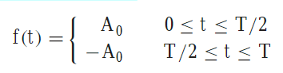

1. Prove that the Fourier Series is:

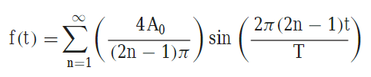

1. Let $A_{0}= 1$ and $T = 0.25 s$. Plot the first six terms of the Fourier series individually, as well as the sum of these six terms.

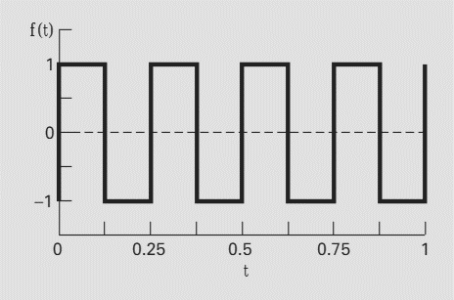

Figure 1

(20 marks)

1. Use Euler’s method in MATLAB to integrate $y' = 4e^{0.8t} - 0.5y$ from $t = 0 to 4$. The initial condition at $t = 0$ is $y = 2$. Note that the exact solution can be determined analytically as:

$$y=\frac{4}{1.3}\left(e^{0.8t}-e^{-0.5t}\right)+2e^{-0.5t}$$

Compare these two solutions by plotting both. Attach your script.

(20 marks)